Travel Demand Modeling
https://www.hrtpo.org/page/travel-models-and-forecasts/
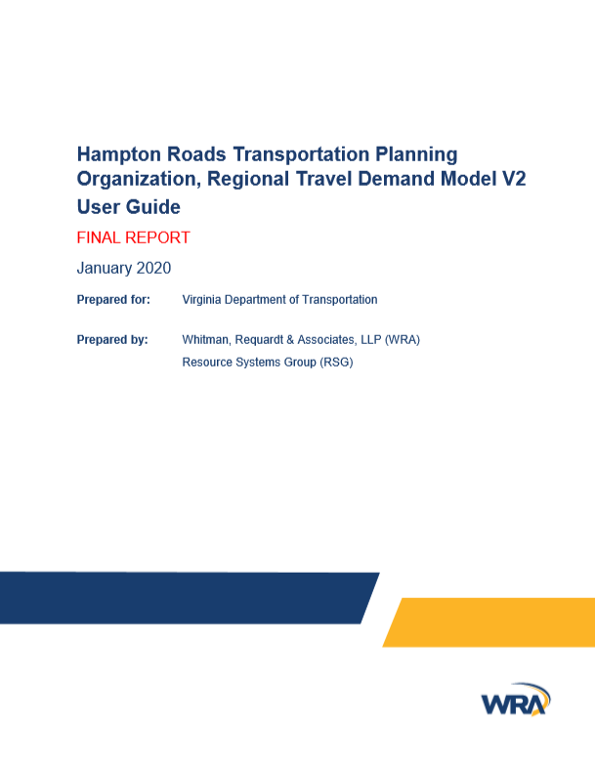 | 2020 Hampton Roads Travel Demand Model (TDM) Technical Documentation  https://www.hrtpo.org/uploads/docs/2020_HamptonRoads_Modelv2_MethodologyReport.pdf
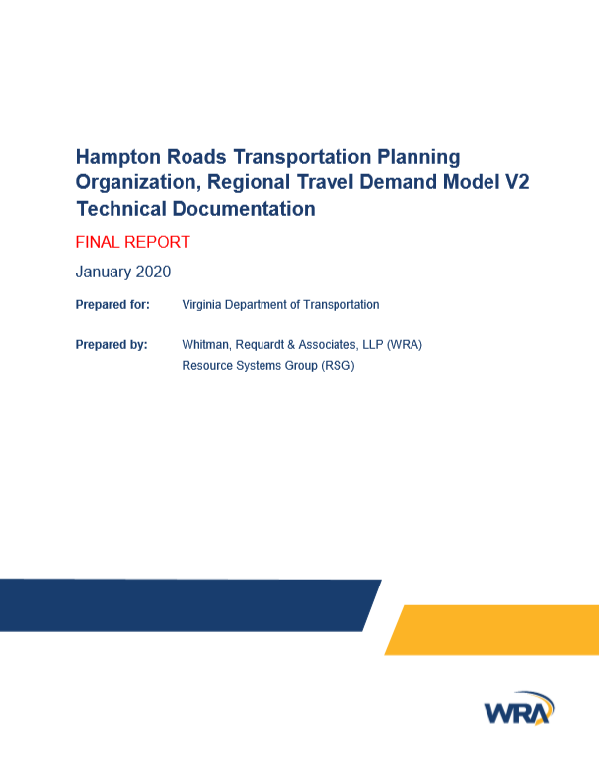 | 2020 Hampton Roads Travel Demand Model (TDM) User’s Guide  https://www.hrtpo.org/uploads/docs/2020_HamptonRoads_Modelv2_UsersGuide.pdf

