Financial Planning/Fiscal-Constraint Documentation: LRTP
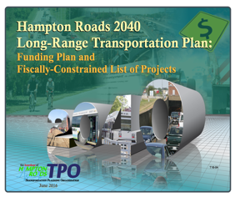 | 2040 LRTP: Funding Plan and Fiscally-Constrained List of Projects  https://www.hrtpo.org/uploads/docs/2040LRTP_FundingPlan_update_10.02.2017.pdf
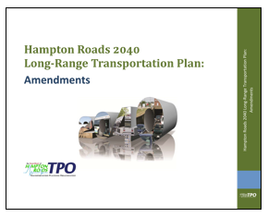 | 2040 LRTP: Amendments Document  https://www.hrtpo.org/uploads/docs/2040LRTP_Amendments.pdf

