2040 Long-Range Transportation Plan
https://www.hrtpo.org/page/2040-long-range-transportation-plan/
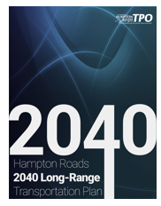 | 2040 LRTP Summary Brochure  https://www.hrtpo.org/uploads/docs/2040LRTP-SummaryBrochure.pdf
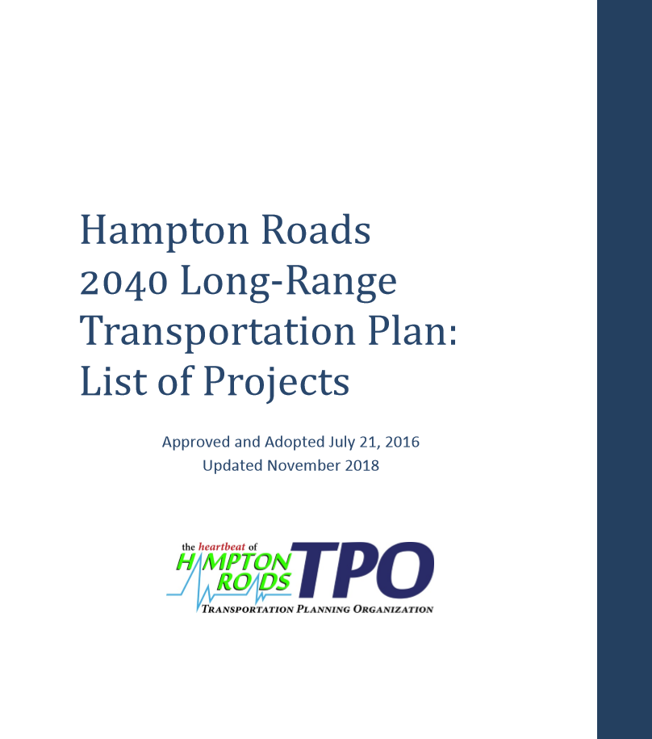 | 2040 LRTP List of Projects  https://www.hrtpo.org/uploads/docs/HR-2040-LRTP-Projects.pdf
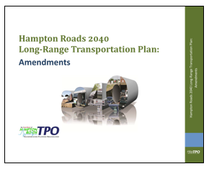 | 2040 LRTP: Amendments Document  https://www.hrtpo.org/uploads/docs/2040LRTP_Amendments.pdf
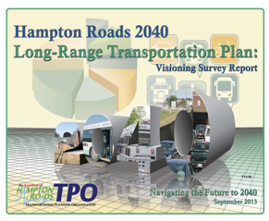 | 2040 LRTP: Visioning Survey Report  https://www.hrtpo.org/uploads/docs/2040%20Long-Range%20Trans%20Plan-Visioning%20Survey%20Report.pdf
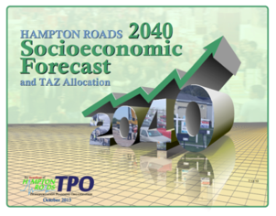 | 2040 Socioeconomic Forecast and TAZ Allocation Report  https://www.hrtpo.org/uploads/docs/HR_2040_SocioeconomicForecast_TAZAllocation_FinalReport.pdf
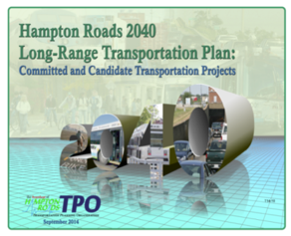 | 2040 LRTP: Committed and Candidate Projects Report  https://www.hrtpo.org/uploads/docs/2040LRTP_Committed_and_Candidate_Transportation_Projects.pd
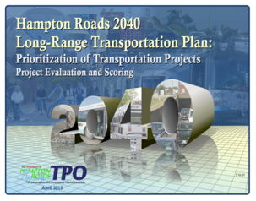 | 2040 LRTP: Prioritization of Transportation Projects Report  https://www.hrtpo.org/uploads/docs/HRTPO_2040LRTP_ProjectPrioritization_FinalReport.pdf
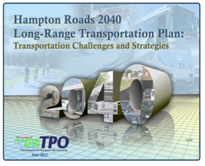 | 2040 LRTP: Transportation Challenges and Strategies Report  https://www.hrtpo.org/uploads/docs/Challenges%20and%20Strategies%20FINAL%20Report.pdf
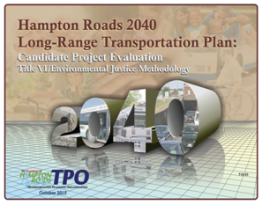 | 2040 LRTP: Title VI/Environmental Justice Methodology Candidate Project Evaluation Report  https://www.hrtpo.org/uploads/docs/101515TPO-Enclosure%2012-Hampton%20Roads%202040%20LRTP-Candidate%20Project%20Evaluation%20Title%20VI-Environmental%20Justice%20Methodology.pdf
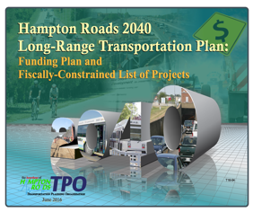 | 2040 LRTP: Funding Plan and Fiscally-Constrained List of Projects Report  https://www.hrtpo.org/uploads/docs/2040LRTP_FundingPlan_update_10.02.2017.pdf
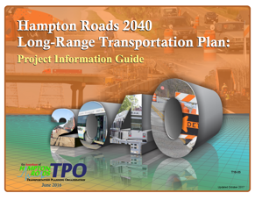 | 2040 LRTP: Project Information Guide  https://www.hrtpo.org/uploads/docs/2040LRTP_Project_Information_Guide_November.pdf
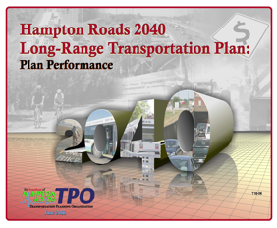 | 2040 LRTP: Plan Performance Report  https://www.hrtpo.org/uploads/docs/2040LRTP_PlanPerformance.pdf
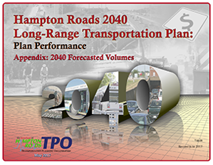 | 2040 LRTP: Plan Performance Appendix (2040 Forecasted Volumes)  https://www.hrtpo.org/uploads/docs/2040%20LRTP%20Plan%20Performance%20Appendix%20Forecasted%20Volumes%20Final_Report_062817.pdf
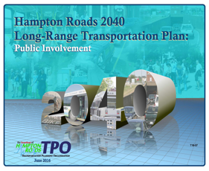 | 2040 LRTP: Public Involvement Report  https://www.hrtpo.org/uploads/docs/2040LRTP_PublicInvolvement.pdf
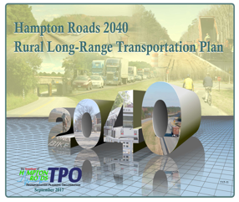 | 2040 Rural Long-Range Transportation Plan  https://www.hrtpo.org/uploads/docs/HR-2040-RLRTP.pdf
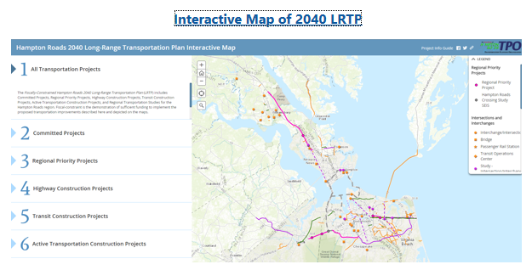 | 2040 LRTP Interactive Map  http://hrpdc-gis.maps.arcgis.com/apps/MapSeries/index.html?appid=6b47cd8cac4245619c1ae71c4e847be5

2045 Long-Range Transportation Plan (update in progress)
https://www.hrtpo.org/page/2045-long_range-transportation-plan/
2045 LRTP Scenario Planning webpage | Scenario Planning for 2045 LRTP  https://www.hrtpo.org/page/2045-long_range-transportation-plan:-scenario-planning/
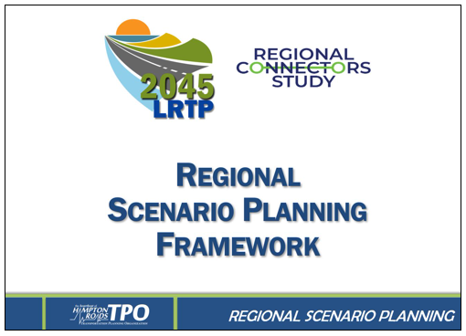 | Board approved 2045 LRTP Regional Scenario Planning Framework  https://www.hrtpo.org/uploads/docs/RegionalScenarioPlanningFramework.pdf
Project Prioritization webpage | HRTPO Project Prioritization  https://www.hrtpo.org/page/project-prioritization/
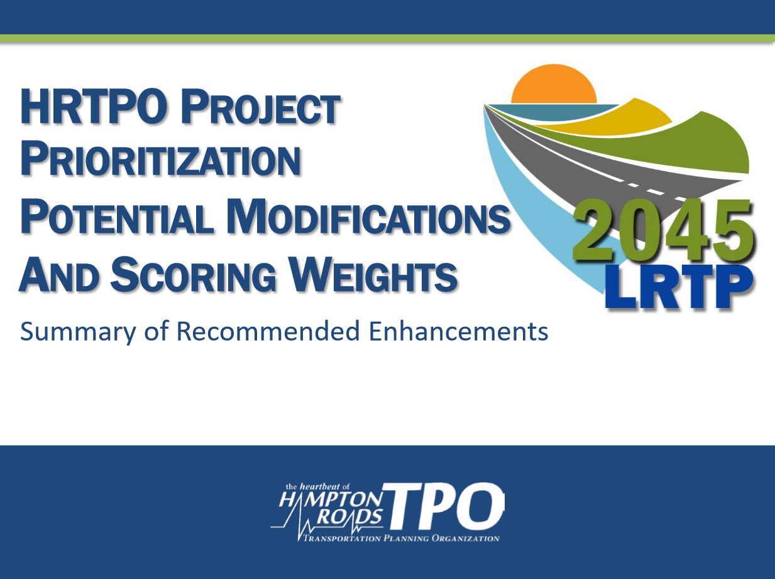 | Summary of recent Board approved Enhancements (to be used in 2045 LRTP)  https://www.hrtpo.org/uploads/docs/020520%2013_Project%20Prioritization-Summary-Recommended%20Enhancements.pdf
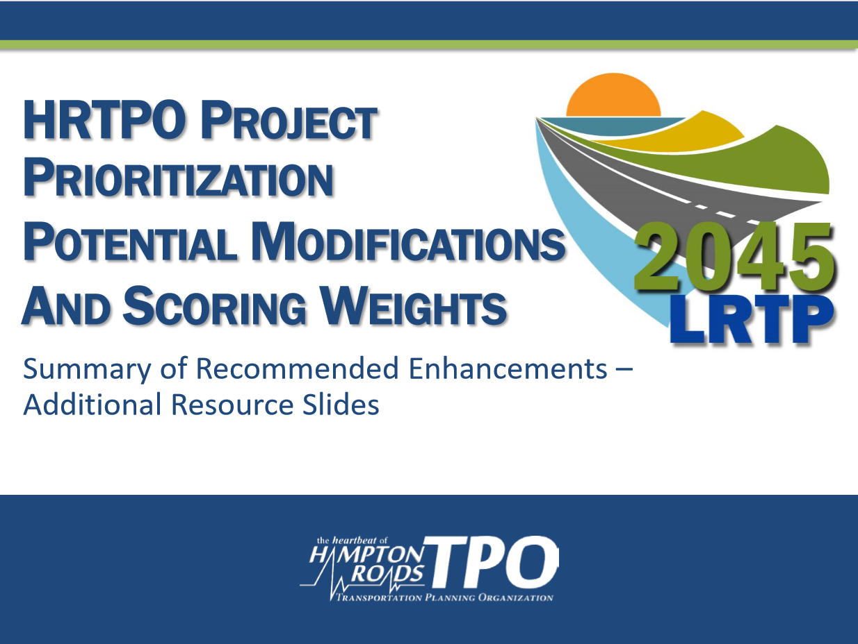 | Summary of Recommended Enhancements – Additional Resource Slides  https://www.hrtpo.org/uploads/docs/B-ProjectPrioritization-Summary-RecommendedEnhancements-AdditionalResources.pdf
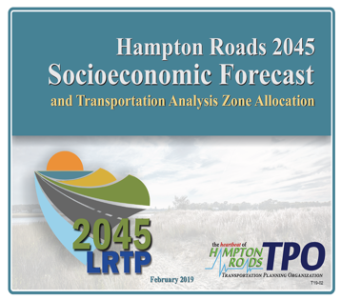 | 2045 Socioeconomic Forecast  https://www.hrtpo.org/uploads/docs/Hampton%20Roads%202045%20Socioeconomic%20Forecast%20and%20TAZ%20Allocation%20Report.pdf
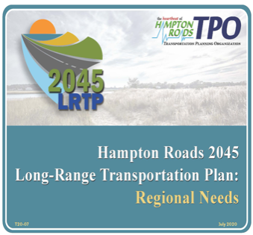 | 2045 LRTP: Regional Needs  https://www.hrtpo.org/uploads/docs/HR_2045LRTP_RegionalNeeds.pdf
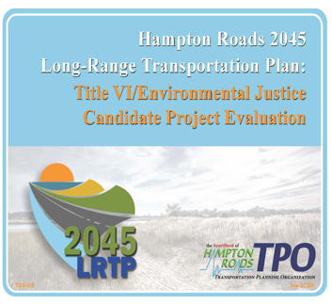 | 2045 LRTP: Title VI/Environmental Justice Candidate Project Evaluation  https://www.hrtpo.org/uploads/docs/HR_2045LRTP_TitleVI-EJ-CandidateProjectEvaluation.pdf
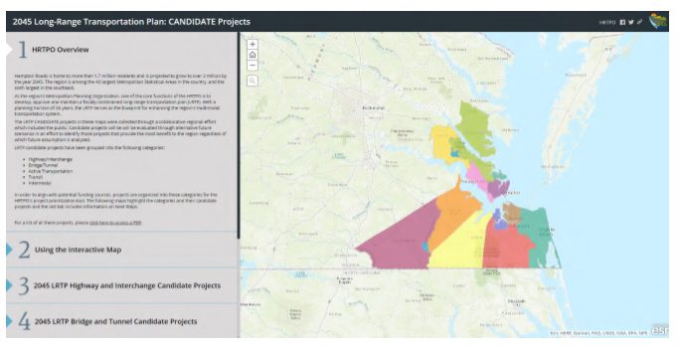 | 2045 LRTP: Candidate Projects Interactive Map  https://hrpdc-gis.maps.arcgis.com/apps/MapSeries/index.html?appid=b8852614e73a42bfa3730963d216f2ab

