Bike and Pedestrian (Active Transportation) Plans
Regional Active Transportation Planning: https://www.hrtpo.org/page/active-transportation/
HRTPO Active Transportation Planning: https://www.hrtpo.org/page/hrtpo-at-planning/
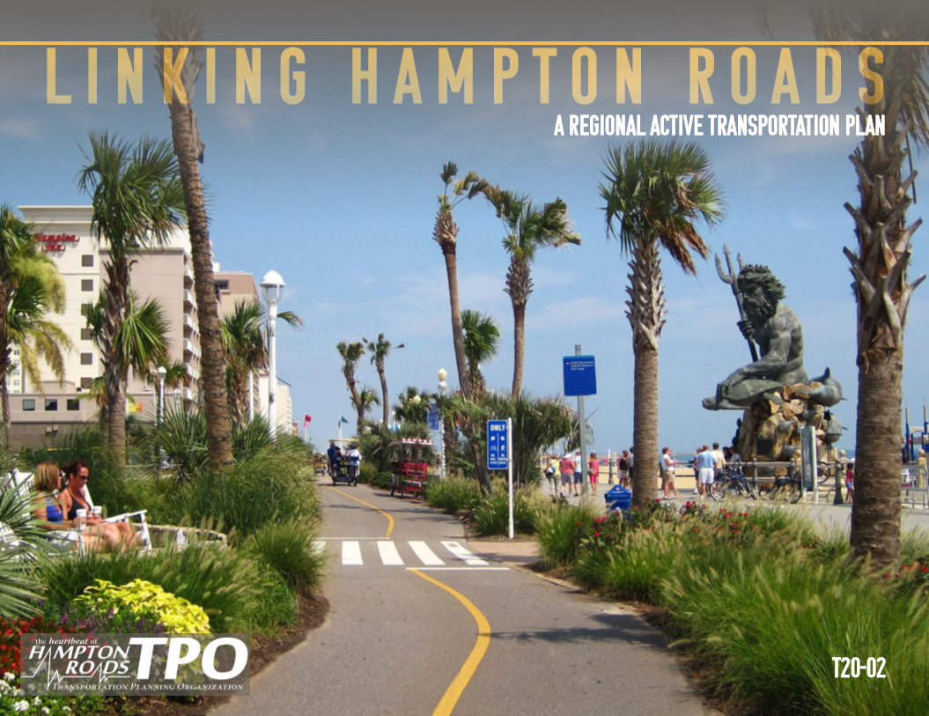 | Linking Hampton Roads – A Regional Active Transportation Plan  https://www.hrtpo.org/uploads/docs/052120%2007G-Enclosure%20Linking%20Hampton%20Roads-A%20Regional%20Active%20Transportation%20Plan%20%281%29.pdf
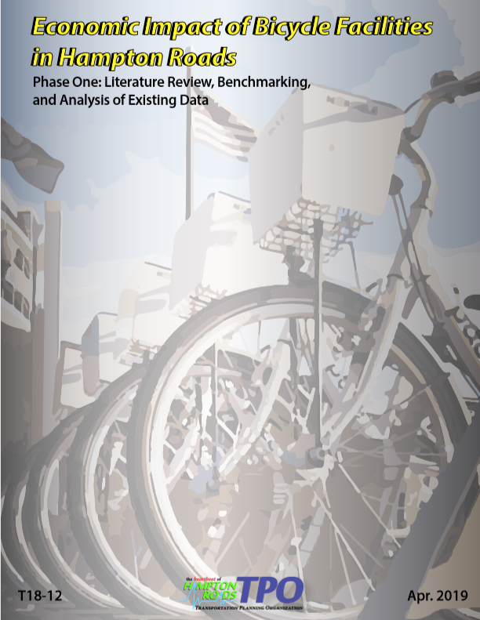 | Economic Impact of Bicycle Facilities in Hampton Roads (Phase One)  https://www.hrtpo.org/uploads/docs/Economic%20Impact%20of%20Bicycle%20Facilities%20in%20Hampton%20Roads-%20Phase%20One.pdf
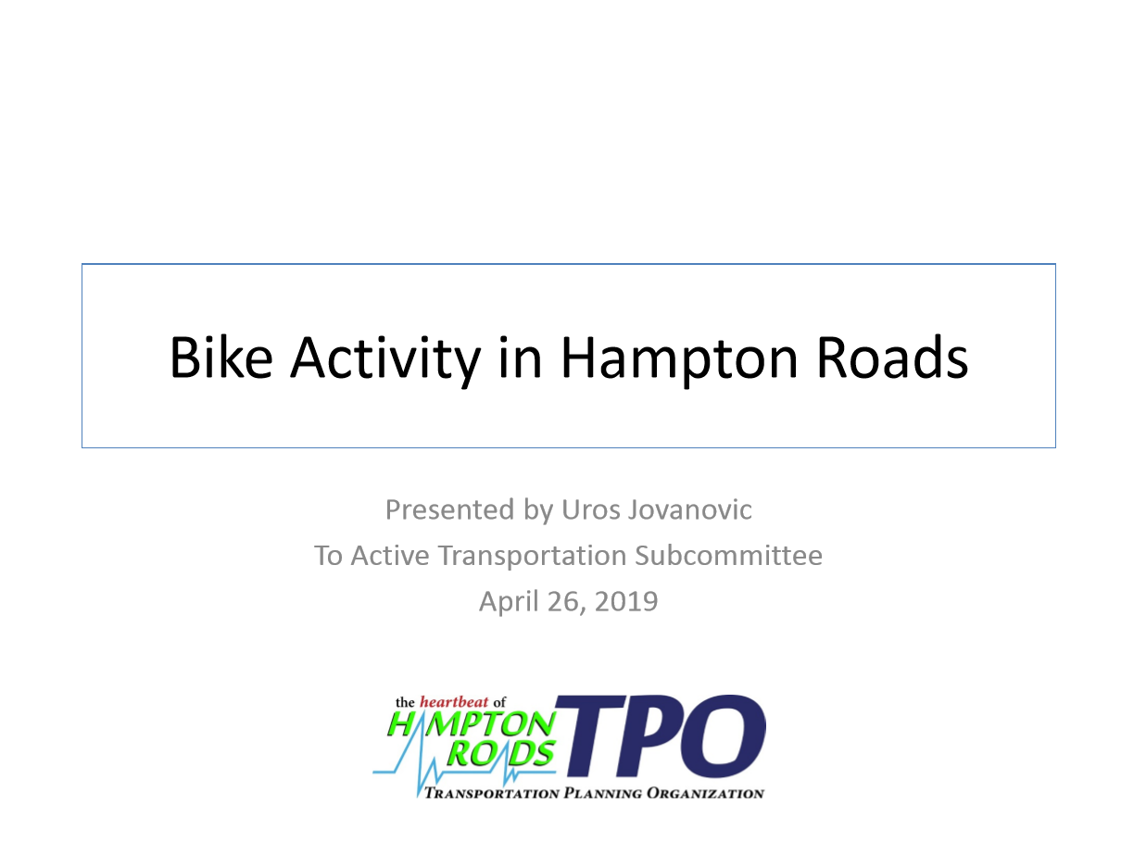 | Bike Activity in Hampton Roads  https://www.hrtpo.org/uploads/docs/042619%2006%20Presentation%20bike%20activity%20in%20Hampton%20Roads.pdf
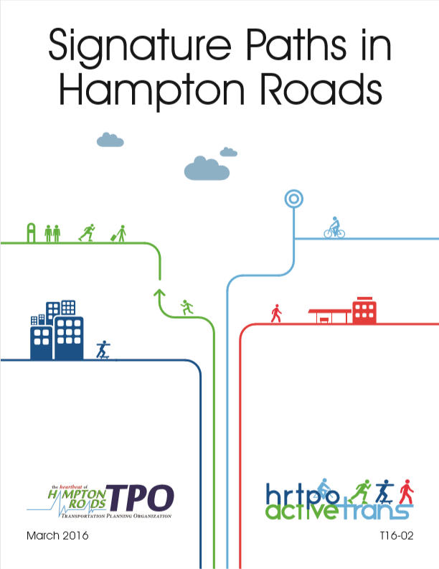 | Signature Paths in Hampton Roads  https://www.hrtpo.org/uploads/docs/Signature%20Paths_T16-02.pdf
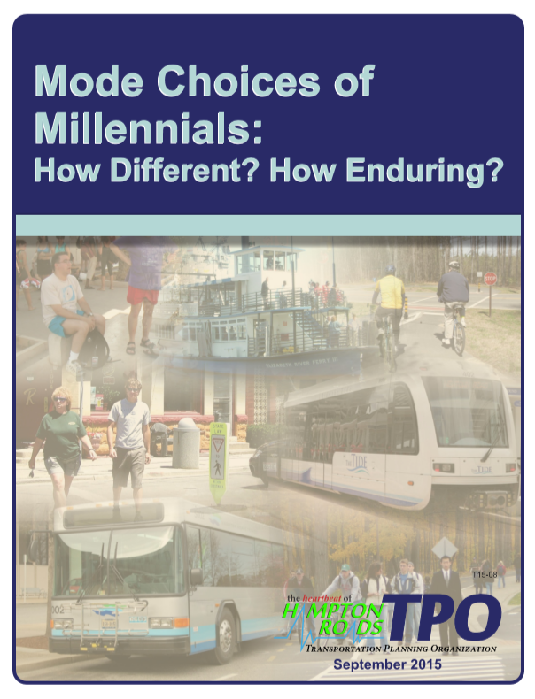 | Mode Choices of Millennials: How Different? How Enduring?  https://www.hrtpo.org/uploads/docs/E11%20-%20090815%20HRTPO%20Millennials%20Final%20Report%20with%20Inside%20Cover.pdf
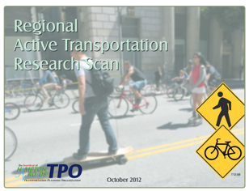 | Regional Active Transportation Research Scan  https://www.hrtpo.org/uploads/docs/T12-08%20Regional%20Active%20Transportation%20Scan.pdf

